Objectives

- Explain about React forms
- Define controlled components
- Explain about various input controls
- Explain about handling forms
- Explain about submitting forms
In this hands-on lab, you will learn how to:
- Implement React forms
- Use various input controls like textbox, button and textarea

Prerequisites

The following is required to complete this hands-on lab:
- Node.js
- NPM
- Visual Studio Code

Notes

Estimated time to complete this lab: 60 minutes.
Create a React App named “ticketraisingapp” which will help to raise a complaint and get it resolved.

Create a component named “ComplaintRegister” with a form containing a textbox to enter the employee name and a textarea to enter the complaint. Use “handleSubmit” event of the button to submit the complaint and generate a Reference number for further follow ups in the alert box.

Output Expected:

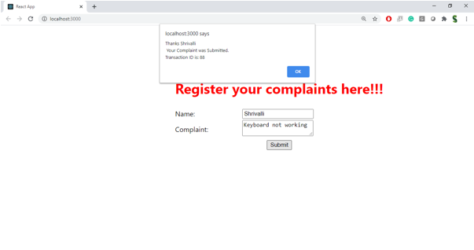

Hint:

